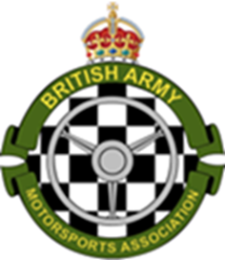

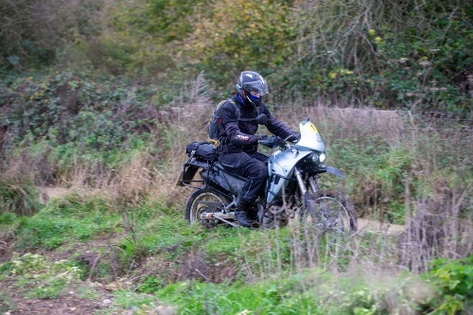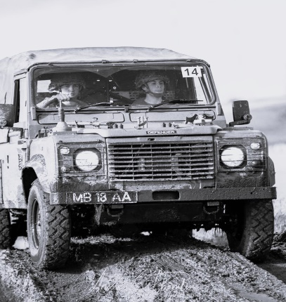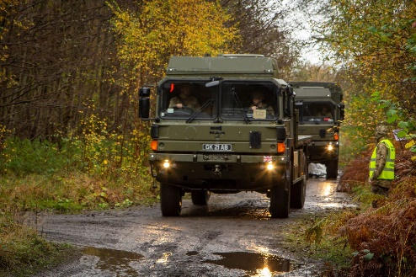

The British Army Motorsports Association
Navigation Group

Supplementary Regulations for Navigation Events 2025

References:

- Motorsport UK National Competition Rules (NCR) The Blue Book 2025
- Auto Cycle Union (Bikesport GB) Regulations www.acu.org.uk
- The BAMA Rules and Regulations (formerly the Charter)
- The BAMA Navigation Group Scrutineering Sheet
- JSP 800 Vol. 5 Road Transport Policy

1. Announcement. The British Army Motorsports Association (BAMA) is to promote and organise a series of safe and skilled driving events during 2025. These events will be of Clubman status (Ref A) and will be open to all wheel drive vehicles and adventure motorcycles which are insured and taxed for use on public roads. The events will all involve a significant element of navigation as well as teamwork between driver and navigator; in the case of motorcycles, this may be between one or more riders competing as a team. Each event will also be covered by a set of Additional Supplementary Regulations (ASR), which will give specific details for that event, in addition to these Supplementary Regulations (SR) for 2025. References to the NCR will be in this format – eg Chapter 13, Appendix 1, paragraph 1, sub paragraph 1.2; abbreviated thus (13,1,1,1.2).

2. Jurisdiction. The events will be run under rules incorporating and governed by the General Regulations of Motorsport UK www.motorsportuk.org incorporating the provisions of the National Sporting Code of the FIA, the Auto Cycle Union www.acu.org.uk, event specific Additional Supplementary Regulations (ASR) and any written instructions that the organizing committee may issue for the event.
3. Authorisation. Motorsport UK and ACU permits will be applied for, and their numbers promulgated in the ASR. DIO licences will be applied for where required. The events will be listed on the ASCB fixture list.

4. Eligibility. The event is open to members of the Armed Forces, who are members of single service motorsports associations, and the clubs and associations listed in the ASR.
All participants in light 4x4 vehicles must hold at least a RS Clubman licence (available at https://www.motorsportuk.org/competitors/rs-clubman-licence/); for motorcycle riders must be registered for Trials in accordance with Auto Cycle Union (ACU) rules.

5. Insurance for Civilian vehicles. Civilian Vehicles must have a valid motor insurance policy which provides as a minimum, Third Party Liability cover that complies with the Road Traffic Act. The Additional Supplementary Regulations for each event will state whether additional insurance is required (e.g. if the event uses a public highway). Third party cover whilst off-road, is covered by the appropriate National Governing Body (NGB).

6. Timings. Full details will be included in the ASR. Competitive phases will be run on schedule time per 13, 5, 7 &10

7. Route. Details of the route presentation and maps required will be issued in the ASR and/or Final Instructions (FI).

8. Controls. These will be as 13, 5, 3 – 6.

9. Sections. These will be defined as standard, neutral or transport in accordance with 13, 4, 3-7 et seq. (See paragraph 26).

10. Identification. R 6.1 Competing vehicles will be identified by small numbers to be placed in the lower nearside wind screen and lower near side rear screen (if fitted). These numbers are to be removed at the end of the event.

11. Classes. Crews will be classed as follows:

- Expert. Where either crew member has competed in 6 or more BAMA navigation events.

- Novice. Where either crew member has competed in 2 or more but less than 6 BAMA navigation events.

- Beginner. Where neither crew member has competed in more than 2 BAMA navigation events.

- Note. Entrants with experience of civilian navigation events will be classified by the event organiser and the decision will not be subject to protest.

12. Teams. Details of team (as opposed to crew) composition and costs will be detailed in the event specific Additional Supplementary Regulations (ASR).

13. Competing Vehicles. All competing vehicles must comply with the following:

- Vehicles must be fitted with all-wheel drive and have at least four wheels and two side by side forward facing front seats which have fitted seat belts. No other seats may be used during the event.

- Vehicles are to be essentially standard, and no special vehicles are permitted. What is a special will be decided by the organisers but will include fire engines and ambulances. Whilst modified vehicles are permitted it must be accepted that, to retain the navigation essence of the event, offroad racers and similar vehicles are not permitted unless fully ‘Road Legal’.

- Vehicles may only have four forward facing beams; ie two headlights and two additional lights.

- Auxiliary LED light bars: these may be permitted on specified events, and this will be confirmed in the ASR for each event. Where they are not permitted, if fitted. these must be disabled.

- Forward-facing roof mounted lights: (either individual lights or lightbars/pods) these are not permitted and if fitted, must be rendered unusable during the event, unless specifically permitted in the ASR. That means covered completely or disconnected from the source of power (not just switched off!). If in doubt, please consult the Event Secretary before entering.

- Rear facing work lamps and additional reversing lamps: these must be fitted with an illuminated warning switch or in the case of an additional reverse light, it may operate when the normal reversing light is illuminated.

- Armed Forces personnel participating in ‘Green Fleet’ vehicles must comply with JSP 800 Vol 5 – Policy Leaflet 10 and 2015DIN10-054.

- Motorcycles must be road legal.

14. Speed. Average and maximum speeds will be detailed in the ASR.

15. Quiet Zones (QZ). These will be made known to competitors prior to starting.

16. Stop. Junctions where a stop is mandated will be made known to competitors prior to starting. At a STOP junction all road wheels must cease to rotate and vehicular velocity must be nil, prior to reaching the stop line. Driving standards marshals will monitor compliance. These are in addition to posted stop junctions for which the same rules apply.

17. Entries. The maximum number of entries will be promulgated in the ASR as will dates when the entry list opens and closes. Details of how to enter, costs of entry and how to make payment. will also be included.

18. Results. Provisional results will be in accordance with 13, 5, 1 et seq. They will be declared final, subject to there being no protests, 30 minutes later. Further details of results will be made known in the FI.

19. Awards. A detailed award list will be shown in the ASR. The following awards are likely to be presented, subject to number of entries:

Ser | Awards | Remarks
1 | 1st Overall | Light 4x4 Class only
2 | 2nd Overall | Light 4x4 Class only
3 | 3rd Overall | Light 4x4 Class only
4 | 1st Expert | Light 4x4 Class only
5 | 1st Novice | Light 4x4 Class only
6 | 1st Beginner | Light 4x4 Class only
7 | 1st Truck
8 | 2nd Truck
9 | 1st Motorcycle
10 | 2nd Motorcycle
11 | Spirit of the Event

20. Documentation. A detailed list of documents required for vehicles and for personnel will be included in the ASR.

21. General Regulations. All general regulations will apply, modified as follows:

- Excessive noise, driving or behaving in a manner which is deemed detrimental to the good reputation of the sport. Disqualification. Judge of fact.

- Deliberately driving off public rights of way, unless directed by an official or the roadbook. Disqualification. Judge of fact.

- Excessive damage to a vehicle. Disqualification. Judge of fact.

- Receiving outside assistance. Disqualification. Judge of fact.

- Breach of regulations as defined. Disqualification. Judge of fact.

- Entering an out of bounds area. Disqualification. Judge of fact.

- Not complying with an instruction for which no penalty is specified, provided that a warning is given. 10 points. Any official.

- Drivers. Where both driver and navigator can meet all the requirements of all regulations each may drive on the event.

22. Fuel. The probable distance of the event and availability of fuel will be shown in the ASR.

23. Scrutineering. All vehicles must be scrutineered prior to starting an event. This could be third party scrutineering, with spot checks on the day or full inspection on the day. Detailed instructions will be in the FI and the scrutineering form is available to download using the link at Ref. D.

24. Service Crews. Service crews are not permitted. Outside, or pre-arranged assistance is an offence.

25. Electronic devices. The use of the following devices is forbidden, on pain of exclusion:

- Radio transmitters/receivers other than those designed for receiving public broadcasts.

- Satellite derived position indicating devices.

- Distance measuring device, other than that fitted as standard during manufacture.

- Speed calculating device other than that fitted as standard during manufacture.

- To remain within the spirit of the event the use of mobile phones for any reason, other than to communicate with other crews or officials in an emergency, is forbidden. *

- Computer or electronic based map systems.

*Note. This could be amended to enable electronic briefings to take place.

26. General Administration. Instructions concerning dress, personal and navigation equipment, accommodation, feeding, hygiene, and PPE will be shown in the ASR.

27. Competitive sections. Specific instructions relating to the following aspects of competitive sections will be explained in the ASR/FI:

- Timing and procedure at manned controls.

- Definition of the various controls and checks on the event.

- The location and length of time of breaks.

- Instructions concerning lateness.

- List of phases.

28. Penalties. A table showing what will be penalised and what the penalties are, will be promulgated in the ASR.

29. Officials. Various officials are required to run these events and will be nominated by the BAMA. They will be on duty and details will be contained in the ASR. Judges of fact and driving standards officers (DSO) mut be detailed in the ASR.

30. Unmanned Aircraft Systems (UAS). Also known as drones, these devices may only be operated in the vicinity of a BAMA event, if:
- The pilot is licenced by the CAA, is accredited to motorsport UK and has an event specific letter of authority.

- To gain Motorsport UK accreditation there must have been issued an event specific written authority from the event senior official. No blanket authorisations will be given.

Note: Many of the areas used on events will be no-fly zones, in which case the use of UAS will not be permitted.

31. Final Instructions. The ASR will show when FI will be issued and to whom.

Green Fleet vehicles authorised under JSP800 Vol 5 Leaflet 10 and 2015DIN10-054 are deemed to comply.

